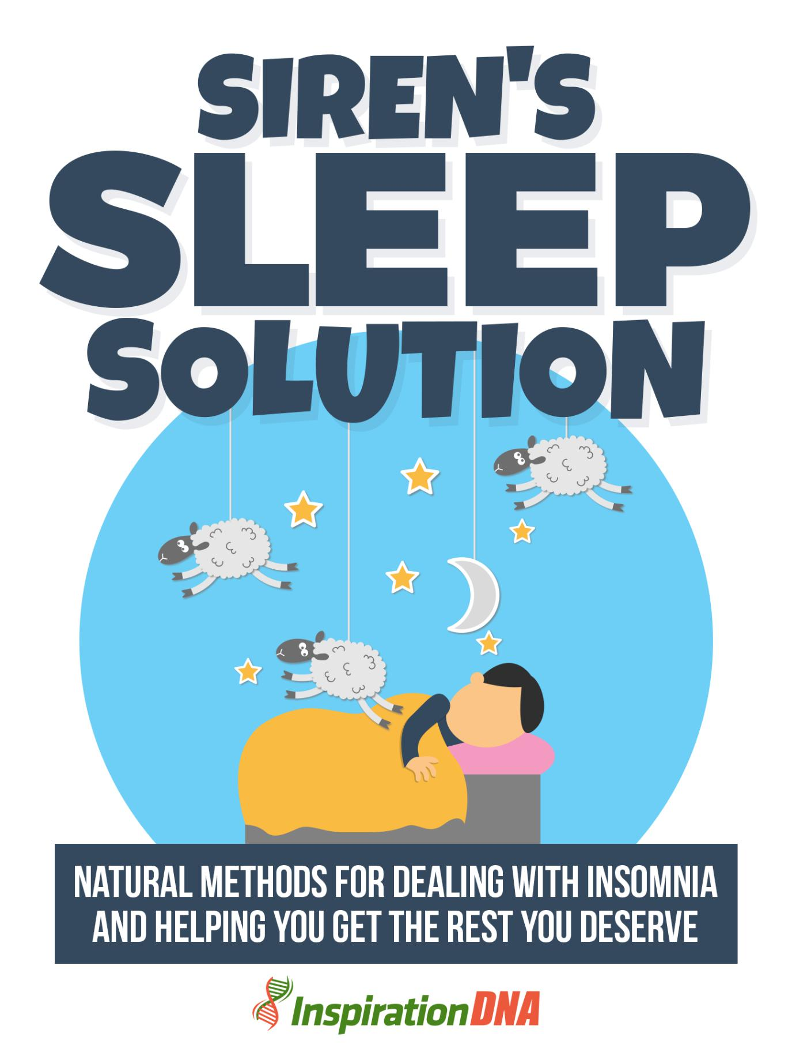

- 1 -

Terms and Conditions

LEGAL NOTICE

The Publisher has strived to be as accurate and complete as possible in the creation of this report, notwithstanding the fact that he does not warrant or represent at any time that the contents within are accurate due to the rapidly changing nature of the Internet.

While all attempts have been made to verify information provided in this publication, the Publisher assumes no responsibility for errors, omissions, or contrary interpretation of the subject Matter herein. Any perceived slights of specific persons, peoples, or organizations are unintentional.

In practical advice books, like anything else in life, there are no guarantees of income made. Readers are cautioned to reply on their own judgment about their individual circumstances to act accordingly.

This book is not intended for use as a source of legal, business, accounting or financial advice. All readers are advised to seek services of competent professionals in legal, business, accounting and finance fields.

You are encouraged to print this book for easy reading.

- 2 -

Table Of Contents

Foreword

Chapter 1:

About Insomnia

Chapter 2:

Meditation

Chapter 3:

Natural Supplements

Chapter 4:

Relaxation Strategies

Chapter 5:

How Diet Comes In

Chapter 6:

What To Do Before Bed

Chapter 7:

Exercise

Wrapping Up

- 3 -

Foreword

Although sleeping tablets may bring a little relief at first, the dangers affiliated with it far outweigh its advantages.

A holistic approach calling for analyzing the frame of mind, dietary habits and life-style may establish permanent relief. The accompanying natural cures have helped me a lot in defeating my insomnia and I trust will help you too in acquiring a deep, peaceful sleep every day.


Siren's Sleep Solution

Natural Methods For Dealing With Insomnia And Helping You Get The Rest You Deserve

- 4 -

Chapter 1:

About Insomnia

If you suffer from insomnia, you don't need me to tell you what insomnia is. All the same, there are assorted types of insomnia and assorted causes of insomnia.


- 5 -

What Is Behind It

There are assorted treatments for insomnias, depending on the type and drive of your insomnia. And they're all natural cures for insomnia - you don't have to fall back on drugs to get a great night's sleep.

Transitory or short-term insomnia happens when you have issues sleeping for a single night or up to a couple of weeks. It's commonly caused by the accompanying factors:

Tension

Shift in your surroundings Temperature extremes
Exterior noise

Medicine side effects

Shift in your sleep schedule, like jet lag

This sort of insomnia commonly sorts itself out and your body's biologic clock will commonly get you back on track.

Intermittent insomnia is if you have short-run insomnia that happens from time to time. It's commonly caused by the same elements as transitory insomnia.

Chronic insomnia is trouble sleeping many nights and lasts at the least a month.

There are additional factors which may drive insomnia. Determine if any of these apply to you:

- 6 -

Habitual pain - individuals with debilitating illnesses have insomnia more

Weight - obese individuals commonly have more sleeping issues Profound weekly drinking

Age - more generally, individuals over sixty are prone to insomnia, but increasingly middle-age (45-64) individuals are getting it

Sex - more females get insomnia than males, particularly during menopause.

History of depressive disorder

While it's common to have the episodic sleepless night, insomnia is the lack of sleep on a steady basis.

Insomnia takes a toll on your vigor, mood, and ability to operate during the day. Chronic insomnia may even contribute to health issues such as heart disease, hypertension, and diabetes. However you don’t have to put up with insomnia. Easy changes to your life-style and daily habits may put a stop to sleepless nights.

Before beginning any natural remedies, confer with your physician. Chronic insomnia may itself be a symptom of a different condition, like clinical depression, heart disease, sleep apnea, lung disease, hot flashes, or diabetes, so it's crucial to see a physician if you're having trouble sleeping.

- 7 -

Chapter 2:

Meditation

Meditation is a centuries-old way of quieting the mind and unwinding the body that may help those who endure insomnia. Meditation brings on deep relaxation, which may cut down sleeping troubles. Research shows that the active procedure of meditation induces the body to “unwind” and quiets the mind, enabling you to fall under a peaceful state of sleep.


- 8 -

Calm

Insomnia is a disorder that leads to hardships in sleeping. The symptoms of insomnia might present themselves as trouble dozing off, difficulty remaining asleep, or early awakening from sleep.

Insomnia causes an individual to feel that sleep is poor or isn't refreshing. Emotional issues like anxiety, tension, and depression are frequently to blame for a lack of regenerating sleep.

Insomnia may be a main disorder in itself, or it may be a symptom of a different disorder. In the latter case, it's called secondary insomnia. Either direction, insomnia leads to disturbed sleep and causes weariness and sleep deprivation for the individual suffering from it.

Meditation is utilized to treat insomnia as meditation methods relax the body and mind and let sleep overtake an individual. It may be utilized in addition to additional conventional treatments, but is likewise effective when utilized alone.

Meditation is simple and is available to everybody. It ought to be tried before utilizing additional sleep aids as it has no enduring side effects. Meditation may clear away the data overload that individuals carry with them from day-to-day life.

Doing away with chronic insomnia will likely take some time and call for long-term changes to bedtime habits. Merely meditating when an individual hasn't altered additional sleep depriving habits might not result in the sought after sleep.

- 9 -

An individual ought to cutback on caffeine, limit alcohol intake, and switch off the television or computer at least 60 minutes prior to bedtime as these are all stimulants; and stimulants, naturally, inhibit relaxation. The purpose of meditation is to unwind the body and mind.

The mere act of “counting sheep” may be considered a sort of meditation. Taking time to “count your blessings” or consider the great things that occurred during the day after lying down in bed at night may likewise be a form of meditating.

The trick is to center on something relaxing and pleasant instead of merely recounting all the events of the day.

Meditation is easy. Some of the times individuals attempt to make it too complicated, which may have the opposite effect of relaxation and produce more stress at bedtime. The advantages of meditation will come with natural relaxation; mediation shouldn't be forced.

A few experts recommend meditating approximately twenty minutes prior to going to bed, while other people advocate meditating in bed. Both strategies may work well and the effects may be the same. It simply depends upon what the meditating individual prefers.

- 10 -

Chapter 3:

Natural Supplements

Today's feverish life-style is taking a toll on over a hundred million Americans power to get the sleep they require. Are you among them?

A lack of sleep may contribute to miserable health, weight gain, untimely aging of the body, mental issues and a lot more. Sleep is the time when your body mends, recharges and restores itself.

Your healthiness is directly affiliated to how much sleep you get, and how peaceful it is. To acquire the sleep they require, many individuals turn to prescription medications or products from the pharmacy. Regrettably a lot of these products may cause an uninvited dependency, morning grogginess and come with serious side effects.


- 11 -

The Natural Way

Kava

Kava is an anti-anxiety herb that might be helpful for anxiety-related insomnia. All the same, the U.S. Food and Drug Administration (FDA) has published an advisory to consumers about the likely risk of serious liver injury resulting from the utilization of dietary supplements containing kava.

Up to now, there have been more than twenty-five reports of serious harmful effects from kava use in other countries, including 4 patients who required liver transplants.

Valerian

Valerian is an herbaceous plant that has been long utilized as a cure for insomnia. Nowadays, it's an accepted nonprescription insomnia remedy in Europe.

Precisely how valerian works in the body is yet not well understood. A few studies indicate that like established sleeping pills, valerian might affect levels of the quieting neurotransmitter GABA.

Contrary to a lot of additional sleep medications, valerian isn't considered to be addictive or induce grogginess in the morning.

- 12 -

However valerian doesn't work for everybody. And while studies in labs have been favorable, clinical tests are still inconclusive.

Valerian is commonly taken between 60 minutes before bedtime. It requires approximately 2 to 3 weeks to work. It should not be utilized for more than 3 months at a time.

Side effects of valerian might include modest indigestion, headache, shakiness, and dizziness. While valerian tea and liquid extracts are available, most individuals don't like the aroma of valerian and prefer taking the capsule kind.

Valerian should not be taken with a lot of medications, particularly those that depress the central nervous system, like sedatives and antihistamines.

Valerian should not be taken with alcoholic beverage, before or following surgery, or by individuals with liver disease. It shouldn't be taken before driving or controlling machinery. Consultation with a certified health practitioner is advocated.

Melatonin

Melatonin is a popular curative to help individuals fall asleep as the sleep/wake cycle has been interrupted, such as in shift workers or individuals who with jet lag.

- 13 -

Melatonin is an endocrine discovered naturally in the body. The pineal gland in the brain creates serotonin which is then changed over into melatonin at night when exposure to light drop-offs.

Melatonin is commonly taken about half-hour before the wanted bedtime. A few experts caution that melatonin shouldn't be utilized by people with depressive disorder, schizophrenia, autoimmune diseases, and additional serious illness. Pregnant and nursing adult females should not utilize melatonin.

The University of Alberta study analyzed seventeen studies with 651 individuals and discovered no significant side effects when utilized for

- months or less. The long-run effect of melatonin supplementation isn't known.
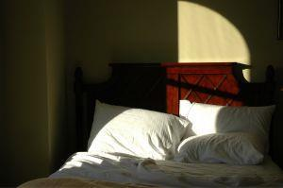

- 14 -

Chapter 4:

Relaxation Strategies

Relaxation strategies are among the most effective ways to expand sleep time, doze off quicker, and feel more rested in the morning. They call for a minimum of twenty minutes prior to going to bed. There are a lot of different techniques:


- 15 -

Catching Z’s

Visualization implies envisaging a relaxing scene. You are able to attempt it in bed before dozing off. Involve all your senses. If you're envisaging yourself on a tropic island, think about the way the tender breeze feels against your skin.

Envisage the fresh aroma of the flowers, view the water and listen to the waves--you get the picture. The more brilliant the visualization and the more senses you call for, the more effective it will become.

Relaxation Response - A mind/body process based on the precepts of Transcendental Meditation.

Discover a quiet place and sit in a comfy position. Attempt to relax your muscles.

Shut your eyes.

Select a focus word, phrase, or prayer that has particular meaning to you, is securely settled in your belief system, or makes you feel peaceful.

Take a breath slowly and naturally. Breathe in through your nose and pause for a couple of seconds. Breathe out through your mouth, once again pausing for a couple of seconds. Wordlessly say your focus word, phrase, or prayer as you breathe out.

Don't fret about how well you're doing and don't feel bad if ideas or feelings intrude. Merely state to yourself "Oh well" and come back to your repetition.

- 16 -

As the time comes to an end, go on to be aware of your breathing but sit quiet. Being aware of where you are, slowly open up your eyes and arise gradually.

This method is commonly practiced for 10 to 20 minutes per day, or at any rate 3 to 4 times a week.

If you have to keep track of the time, attempt utilizing an alarm or timer set on the bottom volume, so you don't have to continue viewing your watch or clock.

Yoga blends deep breathing, meditation, and stretching.

A study discovered that daily yoga for 8 weeks bettered total sleep time, the time to doze off. If you've never attempted yoga before, not to worry. There are a lot of gentle yoga styles to select from.

Progressive Muscle Relaxation is a promising natural curative for sleep.

If you've never attempted a relaxation technique previously, this technique is simple to learn and easy to master.

Here's How:

After discovering a calm place and several free minutes to rehearse progressive muscle relaxation, sit or lie down and make yourself comfy.

Start out by tensing up all the muscles in your face. Create a tight grimace, shut your eyes as tightly as possible, clench your

  - 17 -

teeth, even move your ears up if you are able to. Hold this for the count of 8 as you breathe in.

Now breathe out and relax totally. Let your face go totally lax, like you were sleeping. Feel the tension ooze from your facial muscles, and savor the feeling.

Following, totally tense up your neck and shoulders, once again breathing in and counting to 8. Then breathe out and relax.

Continue down the body, duplicating the procedure with all the muscle groups.

Quickly centering on each group one after the other, with practice you are able to relax your body like ‘liquefied relaxation’ poured on your head and it coursed down and totally covered you. You are able to utilize progressive muscle relaxation to rapidly de-stress any time.


- 18 -

Chapter 5:

How Diet Comes In

You have heard it a 1000 times: if you wish to fall asleep you have to forfeit caffeine. And so you have done that and you yet can't seem to sleep through the night. Well, your diet has an immense bearing on the way you feel particularly if a sleep inadequacy has gotten to be a part of your life. Select foods that encourage sleep instead of keeping you up all night.
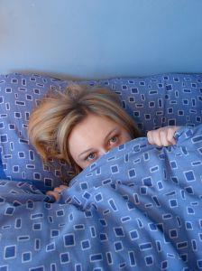

- 19 -

What About Foods

Foods to forestall insomnia

Pumpkin seeds are an awesome source of magnesium which processes to calm the body down. Magnesium assists to relieve the tension that may keep us up all night. Simply 1 oz. of pumpkin seeds bears 151 mg of magnesium, making it among the most magnesium-rich foods out there.

Cottage cheese bears tryptophan, a sleep causing amino acid that loosens up the whole body and mind. If you don't do dairy you are able to likewise find tryptophan in soy milk, tofu, hummus, and lentils.

Sesame seeds are robust in trytophan but they're likewise high in carbs with a medium protein content, perfect for prior to bedtime.

Whole unprocessed grains like brown rice have a calming down effect on the mind. They soothe the nervous system so that the mind quits moving a mile a minute and you are able to doze off. Likewise consider oats for a like effect.

Chlorophyll-rich foods like spinach assist you in getting to sleep. Spinach, like pumpkin seeds, is likewise loaded with magnesium, which sedates and de-stresses the whole body.

  - 20 -

Foods that advance insomnia

Refined carbs drain the body of B complex, which the body requires to release serotonin. If the body can't get adequate serotonin, stress, dread, and depression may keep you up all night.

MSG, frequently found in Chinese food, causes a stimulating response in a few individuals. MSG is nearly always found in processed, refined, and packaged foods.

Bacon holds tyramine, which steps-up the release of norepinephrine, a brain stimulus that keeps you up. Others foods that bear tyramine include chocolate, eggplant, ham, potatoes, sauerkraut, sugar, sausage, tomatoes, and wine.

While a lot of us drink to unwind the body and mind, the fact of the matter is that wine, beer, and spirits may keep you up at night. This is particularly true if you drink more than one. While alcohol may make you tired in the short-term, you're likely to wake in the midst of the night.

Chocolate may raise your energy levels with bioactive compounds like tyramine and phenylethylamine. Chocolate likewise bears sugar which wakes you up as well as the extra obvious culprit, caffeine.

- 21 -

Chapter 6:

What To Do Before Bed

There are some things that will help you sleep better that you can do before turning in for the night.


- 22 -

Habits

As much as possible, hit the sack by 10 p.m. According to research, it's easiest to doze off and the quality of rest is richer if we sack out prior to 10 p.m. You have to have experienced it yourself. If you assume any stimulating action like talking to an acquaintance or watching an intriguing movie after 10 p.m you might discover your sleep un-refreshing.

An exclusion to above rule, hit the sack only if you feel drowsy. Turning in prior to feeling sleepy may produce anxiety regarding arrival of sleep, the major drive of sleeplessness. If you don't drift off inside half an hour of going to bed, get up and meditate or read a book. The same is advised for those who discover themselves awake in the midst of the night. Don't fuss or fight to get to sleep. Any attempt to get to sleep will only make it worse. Remember that a relaxed, unstrained and peaceful brain is the best facilitator for a deep, relaxing sleep.

Abide by the tried and true rule of having a king-sized breakfast, a medium-sized lunch, and a little dinner. Consuming heavy meals before bedtime puts stress on the gastrointestinal system and prevents you from experiencing deep sleep. A light diet rich in carbs like bread or cereals is the most suggested. Unless milk products cause suffering to you, the age old curative of having a glass of milk before bed-time does indeed facilitate better sleep. Fatty and oily foods, confections, ice-creams are energizing and hard to digest, so keep away from them.

If you discover yourself worrying over the onset of sleep, listen to calm pacifying music or a few audio books to distract yourself. Among

- 23 -

the chief reasons insomniacs find it difficult to doze off is because they think a bit much about sleep.

Drink lots of H2O. According to Chinese medicine awakening a lot of times during the night may be due to weakness of the Jing which is stacked away in the kidneys. Drinking enough water flushes out toxins and helps support the kidneys. All the same, minimize your consumption of water after 6 pm to forestall sleep disturbance due to need for urinating.

Rub down your body with oil 1-2 times a week before having a bath. Oil massage is a good way to de-stress. Apart from de-stressing and relaxing, it provides host of advantages like elimination of toxins from the body, lubricate joints, better complexion and relieve fatigue and expand energy levels.

For most individuals, sesame oil will do. All the same, a few might find it a bit hot. They may utilize coconut oil alternatively. One may even add few drops of aromatherapy oils to heighten the experience. An herbalist may specify the correct blend depending on your constitution.

Warm the oil a little. Not on direct flame! Heat a little water in a wide bottom dish and then put the oil container over this water to heat up the oil. Massage the oil all over your body with round motion over flat areas like belly and chest and straight strokes for arms and legs. Let the oil stand for at the least half an hour and then have a warm shower or bath.

- 24 -

Chapter 7:

Exercise

Individuals who regularly employ exercise have fewer episodes of sleeplessness. Physical exertion promotes bettered sleep quality by allowing smoother and steadier transition between the cycles and phases of sleep.
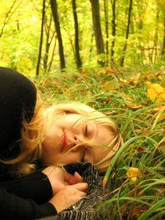

- 25 -

Physical Activity

Moderate physical exertion lasting 20 to 30 minutes 3 or 4 times a week will help you sleep better and provide you more energy. Physical exercise in the morning or afternoon, not around bedtime.

Vigorous physical exertion during the day and mild exercise at bedtime won't only help you doze off and remain asleep more easily but will expand the amount of time you spend in deepest sleep. For a few individuals, exercise alone is sufficient to overcome their sleep issues.

Researchers studied the effects of physical exertion on the sleep patterns of grownups aged 55 to 75 that were sedentary and troubled by insomnia. These grownups were asked to work out for 20 to 30 minutes every other day in the afternoon by walking, enlisting in low-impact aerobics, and riding a stationary bike. The result? The time needed to doze off was cut back by half, and sleep time expanded by nearly 60 minutes.

Physical exertion cuts back tension by helping to break up the lactic acid that accumulates in the blood.

Physical exertion eases the muscular stress that may build up.

Physical exertion sharpens the mind by increasing the sum of oxygen available.

Physical exertion beefs up and stimulates the heart and lungs.

- 26 -

Physical exertion vitalizes the nervous system.

Physical exertion sets off the endocrine system.

Physical exertion increases the body's production of endorphins. Endorphin produces a sense of welfare and increases the body's resistance to pain.

Physical exertion stimulates the release of epinephrine, a hormone that produces a sense of happiness and exhilaration.

Physical exertion abbreviates the boredom, worry, and stress.

Physical exertion betters sleep because it's a physical stressor to the body. The brain makes up for physical stress by increasing deep sleep. Consequently, we sleep more deeply and soundly after physical exertion.

2 determinations about physical exertion are especially relevant to insomniacs.

Insomniacs lead more sedentary lives than great sleepers. The deficiency of physical activeness may contribute to insomnia by curbing the daily rise and fall of the body-temperature rhythm. As a consequence, many individuals get caught in a cycle of insomnia, abbreviated energy and physical activity, and aggravated insomnia.

Physical exertion betters sleep by producing an important rise in body temperature, accompanied by a compensatory drop a couple of hours

- 27 -

later. The drop in body temperature, which endures for 2 to 4 hours after physical exertion, makes it simpler to doze off and remain asleep.

The physical exertion you choose ought to involve vigorous utilization of your legs if it ought to assist with your sleep. The weariness produced by utilizing leg muscles acts as an ataractic agent. Aerobics are the best to battle sleeplessness.

These exercises expand the amount of oxygen that gets to the blood. Illustrations of aerobics are: jogging, swimming, riding a bike, jump rope, dance, riding a stationary bike, utilizing a treadmill, and walking.

A modest workout for 15 to 20 minutes a day, 4 days a week, will be adequate for you to feel the advantages. Stretch prior to and following anything vigorous. Let yourself cool-down following exercising, before you stretch.

For a lot of individuals, the ideal time to work out is early in the morning. However for combating insomnia, the best time to work out is at the end of the afternoon or in the early evening.

If possible, all the same, prevent exercise in the late evening or just prior to turning in. Physical exertion is stimulating to the body. It may take quite a while for your muscles and circulation system to settle down again after a vigorous exercise.

Modest, non-aerobic exercise might help you relax at the end of the day.

- 28 -

Take an easy walk breathing deeply and letting yourself respond to the physical sensation of being outdoors.

Easy dancing to pleasant music may help you lift your mood and loosen up your body.

Yoga and stretching workouts are great ways to wind down.


- 29 -

Wrapping Up

While prescription sleep medicines may supply temporary relief, it’s crucial to comprehend that sleeping pills are not a remedy for insomnia.

And if not utilized cautiously, they in reality make insomnia worse in the long-term. It’s best to utilize medicine only as a last resort, and then, only on a really limited, as-needed basis.

1st, attempt changing your sleep habits, your day-to-day routine, and your mental attitude about sleep. Evidence demonstrates that life-style and behavioral alterations make the biggest and most lasting difference when it comes to insomnia.
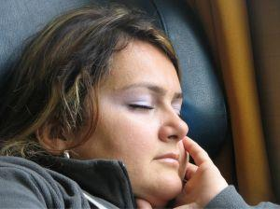

- 30 -

